Title of the Event | Alumni Talk | 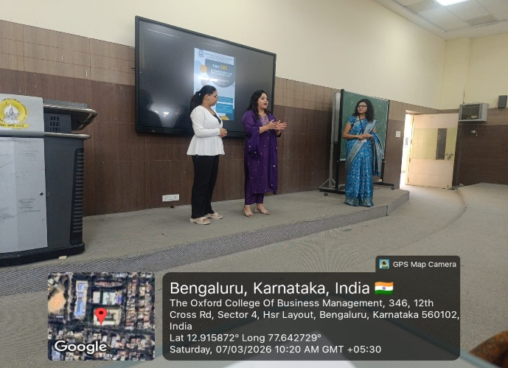
Day and Date | 7 March 2026
Venue (With all details ) | Room No- 407
In collaboration with ( if any)
Details of Resource Person With Designation | Ms. Shreya Nagaraj, Project Analyst at Medtrix Healthcare Communication Service Pvt. Ltd  Ms. Soundarya Swamy, Operation Associate at Accenture Solution Pvt. Ltd. | 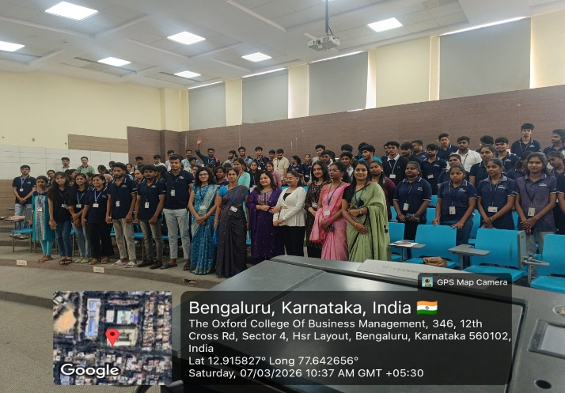
Organizing Department/Coordinators | Commerce and Management Department
Course and semester | UG,PG Management students
No of Students & Faculty Participants | 80

Coordinator HoD Vice-Principal Principal

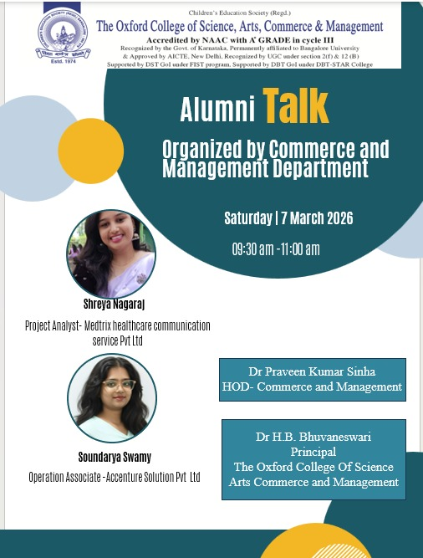
Introduction
The Department of Commerce and Management of The Oxford College of Science, Arts, Commerce and Management organized an Alumni Talk on 7 March 2026 (Saturday) from 9:30 AM to 11:00 AM. The session aimed to provide students with industry exposure and motivate them through the experiences of successful alumni. The talk was delivered by Ms. Shreya Nagaraj, Project Analyst at Medtrix Healthcare Communication Service Pvt. Ltd., and Ms. Soundarya Swamy, Operation Associate at Accenture Solution Pvt. Ltd.
Description of the Activity
The session was conducted for UG and PG students of the Commerce and Management Department. The alumni speakers shared their academic journey, career growth, and professional experiences after completing their studies. Ms. Shreya Nagaraj explained the importance of analytical skills, communication, and continuous learning in the corporate world. Ms. Soundarya Swamy spoke about her experience in the IT industry and highlighted the importance of skill development, adaptability, and professionalism. The session was interactive, and students actively engaged with the speakers by asking questions related to career opportunities and workplace experiences.
Outcome of the Activity
The session helped students gain valuable insights into corporate work culture and career opportunities. It motivated them to focus on skill development and prepare themselves for professional challenges.
Conclusion
The Alumni Talk was an informative initiative by the Department of Commerce and Management. The session provided students with practical knowledge about career development and industry expectations, making it a beneficial learning experience.

